**Code with GPU and GPU offloading**

**PA5.cu**

#include <iostream>

#include <vector>

#include <chrono>

#include <cuda_runtime.h>

using namespace std;

#define BLOCK_SIZE 1024

__global__ void getSumGPU(double* inputArray,double* outputArray, int len){

__shared__ double partialSum[2*BLOCK_SIZE];

unsigned int t = threadIdx.x;

size_t start = 2 * (size_t)blockIdx.x * BLOCK_SIZE;

if (start + t < len)

partialSum[t] = inputArray[start + t]; //first index

else

partialSum[t] = 0;

if (start + BLOCK_SIZE + t < len)

partialSum[BLOCK_SIZE + t] = inputArray[start + BLOCK_SIZE + t];

else

partialSum[BLOCK_SIZE + t] = 0; //last index

for (unsigned int stride = BLOCK_SIZE; stride >= 1; stride >>= 1) {

__syncthreads();

if (t < stride)

partialSum[t] += partialSum[t + stride];

}

if (t == 0)

outputArray[blockIdx.x] = partialSum[0];

}

double getSumCPU(vector<double>& array){

int rows = array.size();

double sum = 0.0;

for(int i = 0; i<rows; i++){

sum += array[i];

}

return sum;

}

int main(int argc, char* argv[]){

int N = stoi(argv[1]);

vector<double> array(N);

for(int i = 0; i<N; i++){

array[i] = i+1;

}

auto start = chrono::high_resolution_clock::now();

double result = getSumCPU(array);

auto end = chrono::high_resolution_clock::now();

chrono::duration<double> elapsed = end - start;

cout << "N: " << N << ",CPU Time: " << elapsed.count() <<

"s, Result = " << result << endl;

int numInputElements = N;

int numOutputElements = (numInputElements + (2 * BLOCK_SIZE) - 1) / (2 * BLOCK_SIZE);

double *d_input, *d_output;

cudaMalloc((void**)&d_input, numInputElements * sizeof(double));

cudaMalloc((void**)&d_output, numOutputElements * sizeof(double));

cudaMemcpy(d_input, &array[0], numInputElements*sizeof(double),cudaMemcpyHostToDevice);

auto gpu_start = chrono::high_resolution_clock::now();

double* GPUSum;

cudaMalloc((void**)&GPUSum, sizeof(double));

while (numInputElements > 1) {

int gridSize = (numInputElements + 2 * BLOCK_SIZE - 1) / (2 * BLOCK_SIZE);

dim3 dimGrid(gridSize, 1, 1);

dim3 dimBlock(BLOCK_SIZE, 1, 1);

getSumGPU<<<dimGrid, dimBlock>>>(d_input, d_output, numInputElements);

cudaDeviceSynchronize();

cudaMemcpy(d_input, d_output, gridSize * sizeof(double), cudaMemcpyDeviceToDevice);

numInputElements = gridSize;

}

double final_GPU_Sum;

cudaMemcpy(&final_GPU_Sum, d_output, sizeof(double), cudaMemcpyDeviceToHost);

auto gpu_end = chrono::high_resolution_clock::now();

chrono::duration<double> gpu_elapsed = gpu_end - gpu_start;

cout<< "GPU Result = " << final_GPU_Sum << endl;

cout << "GPU Time = " << gpu_elapsed.count() << "s" << endl;

cout << "Speedup = " << elapsed.count()/gpu_elapsed.count() << endl;

return 0;

}

Console Log

**Makefile Output** -   
  
Running PA5 CPU vs GPU...

Running N=2^10 array size

Running N=2^11 array size

Running N=2^12 array size

Running N=2^13 array size

Running N=2^14 array size

Running N=2^15 array size

Running N=2^16 array size

Running N=2^17 array size

Running N=2^18 array size

Running N=2^19 array size

Running N=2^20 array size

Running N=2^21 array size

Running N=2^22 array size

Running N=2^23 array size

Running N=2^24 array size

Running N=2^25 array size

Running N=2^26 array size

Running N=2^27 array size

Running N=2^28 array size

Running N=2^29 array size

Running N=2^30 array size

Code Output -   
  
N: 1024,CPU Time: 2.174e-06s, Result = 524800

GPU Result = 524800

GPU Time = 0.00854512s

Speedup = 0.000254414

N: 2048,CPU Time: 4.278e-06s, Result = 2.09818e+06

GPU Result = 2.09818e+06

GPU Time = 0.0074499s

Speedup = 0.000574236

N: 4096,CPU Time: 8.507e-06s, Result = 8.39066e+06

GPU Result = 8.39066e+06

GPU Time = 0.0086051s

Speedup = 0.000988599

N: 8192,CPU Time: 1.6962e-05s, Result = 3.35585e+07

GPU Result = 3.35585e+07

GPU Time = 0.00645866s

Speedup = 0.00262624

N: 16384,CPU Time: 3.3854e-05s, Result = 1.34226e+08

GPU Result = 1.34226e+08

GPU Time = 0.00735273s

Speedup = 0.00460428

N: 32768,CPU Time: 6.7698e-05s, Result = 5.36887e+08

GPU Result = 5.36887e+08

GPU Time = 0.00861531s

Speedup = 0.00785787

N: 65536,CPU Time: 0.000135247s, Result = 2.14752e+09

GPU Result = 2.14752e+09

GPU Time = 0.00698456s

Speedup = 0.0193637

N: 131072,CPU Time: 0.000270474s, Result = 8.59e+09

GPU Result = 8.59e+09

GPU Time = 0.00668376s

Speedup = 0.0404674

N: 262144,CPU Time: 0.000540907s, Result = 3.43599e+10

GPU Result = 3.43599e+10

GPU Time = 0.00958501s

Speedup = 0.0564326

N: 524288,CPU Time: 0.00108187s, Result = 1.37439e+11

GPU Result = 1.37439e+11

GPU Time = 0.00771357s

Speedup = 0.140256

N: 1048576,CPU Time: 0.00217384s, Result = 5.49756e+11

GPU Result = 5.49756e+11

GPU Time = 0.00955751s

Speedup = 0.227448

N: 2097152,CPU Time: 0.00433697s, Result = 2.19902e+12

GPU Result = 2.19902e+12

GPU Time = 0.00706873s

Speedup = 0.613544

N: 4194304,CPU Time: 0.00868877s, Result = 8.7961e+12

GPU Result = 8.7961e+12

GPU Time = 0.00606459s

Speedup = 1.43271

N: 8388608,CPU Time: 0.0175367s, Result = 3.51844e+13

GPU Result = 3.51844e+13

GPU Time = 0.00860528s

Speedup = 2.0379

N: 16777216,CPU Time: 0.0348497s, Result = 1.40737e+14

GPU Result = 1.40737e+14

GPU Time = 0.00857768s

Speedup = 4.06283

N: 33554432,CPU Time: 0.0695161s, Result = 5.6295e+14

GPU Result = 5.6295e+14

GPU Time = 0.00926558s

Speedup = 7.50262

N: 67108864,CPU Time: 0.139139s, Result = 2.2518e+15

GPU Result = 2.2518e+15

GPU Time = 0.00716672s

Speedup = 19.4146

N: 134217728,CPU Time: 0.277954s, Result = 9.0072e+15

GPU Result = 9.0072e+15

GPU Time = 0.00922489s

Speedup = 30.1309

N: 268435456,CPU Time: 0.556686s, Result = 3.60288e+16

GPU Result = 3.60288e+16

GPU Time = 0.01134s

Speedup = 49.0904

N: 536870912,CPU Time: 1.13623s, Result = 1.44115e+17

GPU Result = 1.44115e+17

GPU Time = 0.0113645s

Speedup = 99.9803

N: 1073741824,CPU Time: 5.90211s, Result = 5.76461e+17

GPU Result = 5.76461e+17

GPU Time = 0.019811s

Speedup = 297.921

**Results**

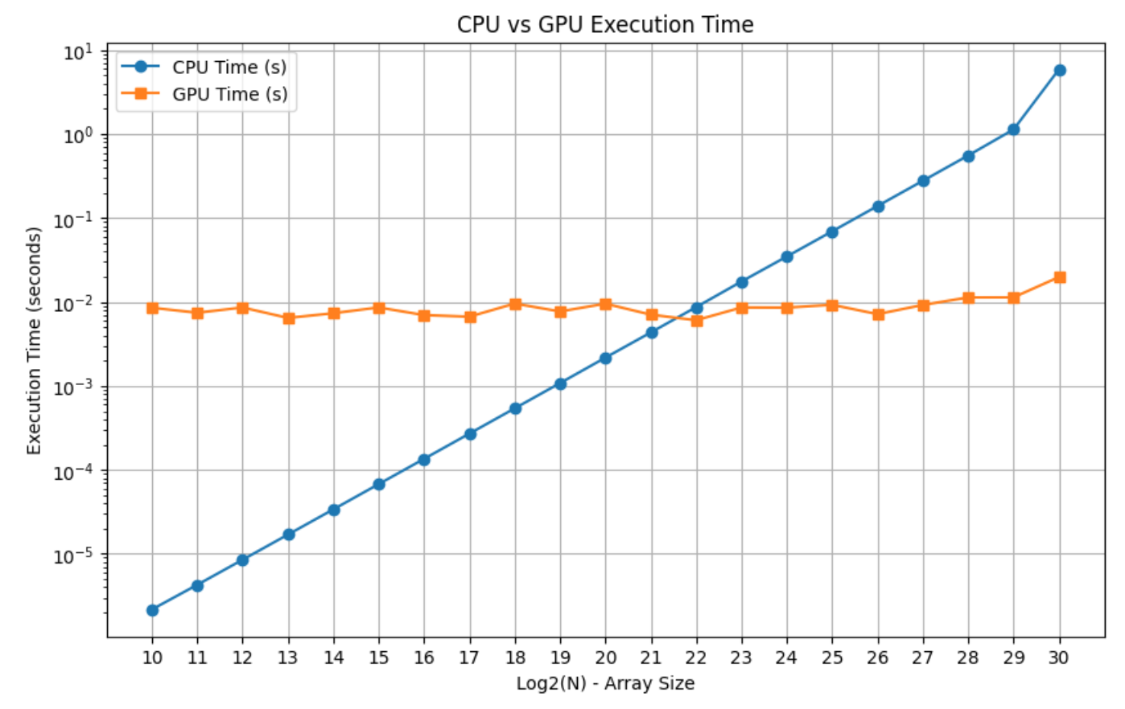

As seen from the CPU vs GPU Execution Time vs Execution Time plot, I am seeing breakeven around 2^22 N (4194304). The GPU graph stays constant for almost all values of N, while for CPU there is linear increase in time taken with increase in N.   
  
Below attached is the time comparison and speed up table for all values of N.

|  |  |  |  |  |  |
| --- | --- | --- | --- | --- | --- |
| **N** | **CPU Time (s)** | **CPU Result** | **GPU Time (s)** | **GPU Result** | **Speed Up** |
| **1024** | 2.174E-06 | 524800 | 0.00854512 | 524800 | 0.000254414 |
| **2048** | 4.278E-06 | 2098180 | 0.0074499 | 2098180 | 0.000574236 |
| **4096** | 8.507E-06 | 8390660 | 0.0086051 | 8390660 | 0.000988599 |
| **8192** | 1.6962E-05 | 33558500 | 0.00645866 | 33558500 | 0.00262624 |
| **16384** | 3.3854E-05 | 134226000 | 0.00735273 | 134226000 | 0.00460428 |
| **32768** | 6.7698E-05 | 536887000 | 0.00861531 | 536887000 | 0.00785787 |
| **65536** | 0.000135247 | 2147520000 | 0.00698456 | 2147520000 | 0.0193637 |
| **131072** | 0.000270474 | 8590000000 | 0.00668376 | 8590000000 | 0.0404674 |
| **262144** | 0.000540907 | 34359900000 | 0.00958501 | 34359900000 | 0.0564326 |
| **524288** | 0.00108187 | 137439000000 | 0.00771357 | 137439000000 | 0.140256 |
| **1048576** | 0.00217384 | 549756000000 | 0.00955751 | 549756000000 | 0.227448 |
| **2097152** | 0.00433697 | 2199020000000 | 0.00706873 | 2199020000000 | 0.613544 |
| **4194304** | 0.00868877 | 8796100000000 | 0.00606459 | 8796100000000 | 1.43271 |
| **8388608** | 0.0175367 | 35184400000000 | 0.00860528 | 35184400000000 | 2.0379 |
| **16777216** | 0.0348497 | 140737000000000.0 | 0.00857768 | 140737000000000.0 | 4.06283 |
| **33554432** | 0.0695161 | 562950000000000.0 | 0.00926558 | 562950000000000.0 | 7.50262 |
| **67108864** | 0.139139 | 2251800000000000.0 | 0.00716672 | 2251800000000000.0 | 19.4146 |
| **134217728** | 0.277954 | 9007200000000000.0 | 0.00922489 | 9007200000000000.0 | 30.1309 |
| **268435456** | 0.556686 | 3.60288E+16 | 0.01134 | 3.60288E+16 | 49.0904 |
| **536870912** | 1.13623 | 1.44115E+17 | 0.0113645 | 1.44115E+17 | 99.9803 |
| **1073741824** | 5.90211 | 5.76461E+17 | 0.019811 | 5.76461E+17 | 297.921 |